[](https://vk.com/photo-104002661_456250680)

[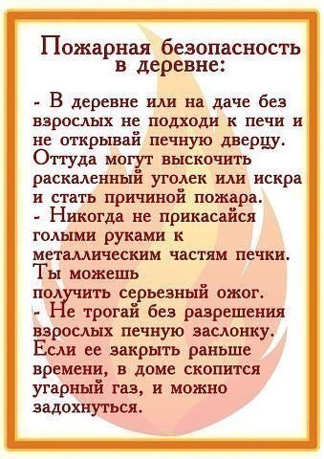](https://vk.com/photo-104002661_456250681)

[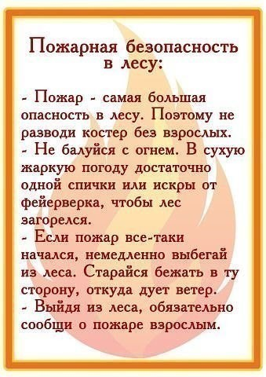](https://vk.com/photo-104002661_456250682)