[](https://vk.com/photo-162044382_456248731)

[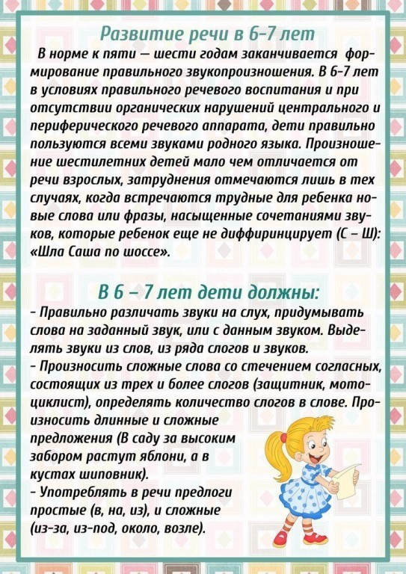](https://vk.com/photo-162044382_456248732)

[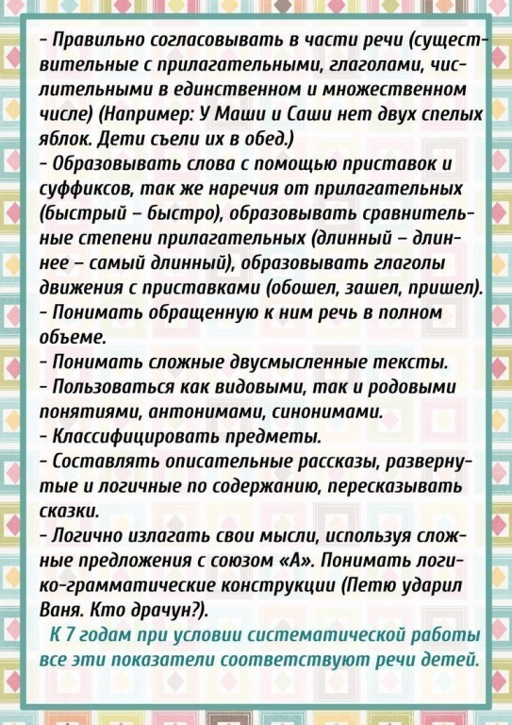](https://vk.com/photo-162044382_456248733)